n_influ=100

n_comm=2000

n_bots=100

random_const=0.2

The distribution around 300 are from the influencers, small peak around 20 is from robots.

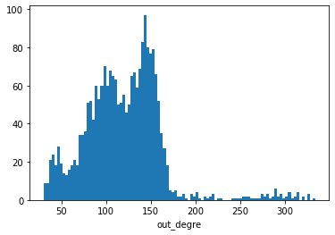

The peak in zero is robots.

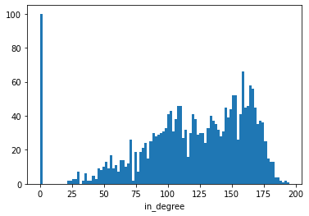

If we only have common nodes:

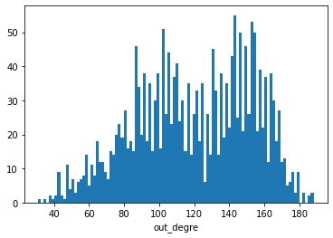

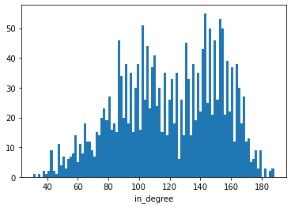

Initial network with

n_influ=4

n_comm=200

n_bots=4

random_const=0.2

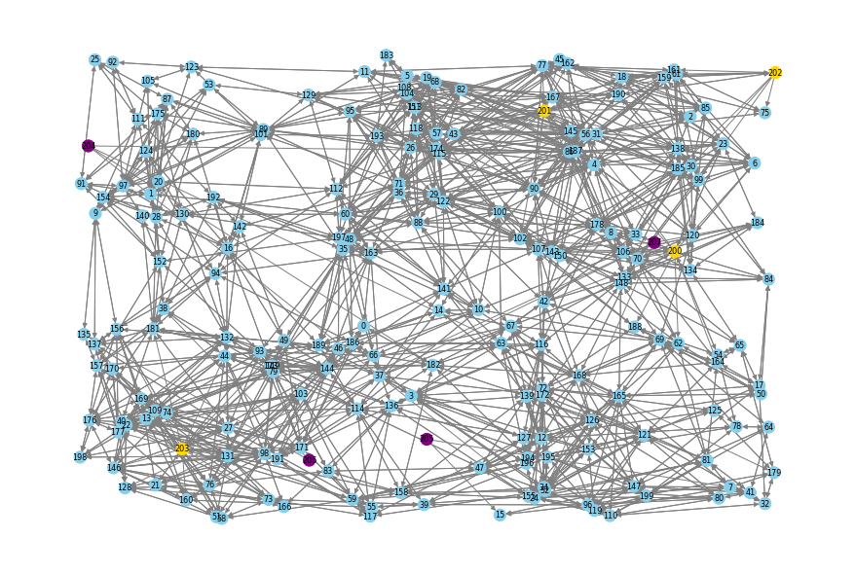

After simulation set time 60 with engagement_news=1:

if 0.5 > node.score > -0.5:

color_map.append("skyblue")

elif node.score > 0.5:

color_map.append("red")

else:

color_map.append("blue")

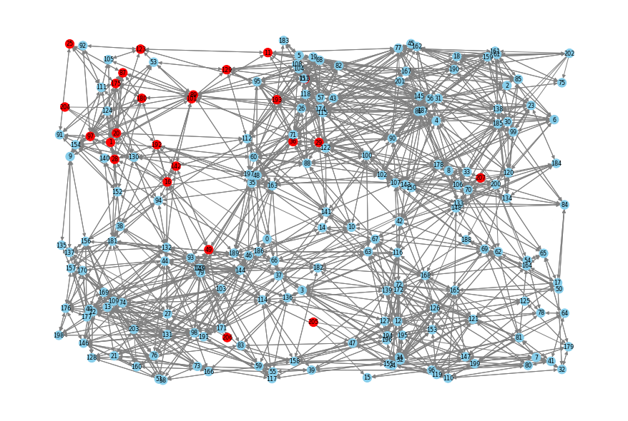

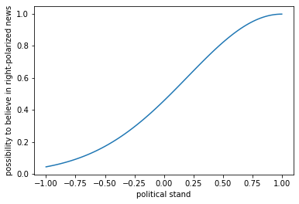

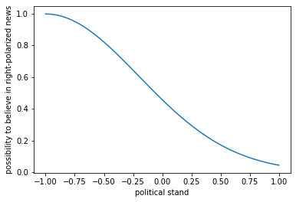

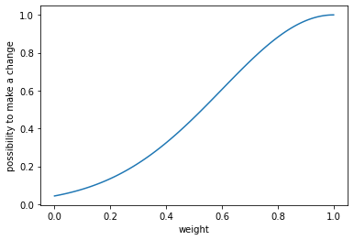

class Node:

def __init__(self,ids,node_type):

self.id=ids

self.type=node_type

self.adj = []

self.score = norm_sample(avg=0,var=0.3,clip1=-1,clip2=1)

def compute_distance(self,node_b):

a = np.array([self.position_x, self.position_y,self.score])

b = np.array([node_b.position_x, node_b.position_y,node_b.score])

return euclidean_distance(a, b)/np.sqrt(2)

def generate_bots(self,random_const,lim=None):

n=0

if lim==None:

lim=self.N_bots

while n < lim:

idx = self.gen_node(NodeType.Bot)

self.nodes[idx].score = np.random.choice([-1,1]) ###now assume bots are fully biased

def initial_infection(self, first_infect):

if first_infect is None:

first_infect = np.random.randint(0,self.N) ###everytime choose one influencer or bots to spread

self.update_score(first_infect,'initial')

return first_infect ###index of the infected node

def update_score(self,index,news):

if news=='initial':

p=np.random.uniform(0,1)

if p<0.5:

self.propagate(index,'left')

else:

self.propagate(index,'right')

return

#if self.visited[index]==1:

# return

score=self.sim_network.nodes[index].score

sigma=0.8

if news=='left':

p=np.random.uniform(0,1)

left_pol=np.exp(-0.5*((score+1)/sigma)**2)

if p<left_pol:

self.sim_network.nodes[index].score-=0.02

self.propagate(index,news)

if news=='right':

p=np.random.uniform(0,1)

right_pol=np.exp(-0.5*((score-1)/sigma)**2)

if p<right_pol:

self.sim_network.nodes[index].score+=0.02

self.propagate(index,news)

def simulate(self, max_time,first_infect=None):

self.events_queue = PriorityQueue() #######the event will happen through this

self.sim_network = copy.deepcopy(self.network)

self.score_list=[]

for i in range(0, max_time):

self.visited=[0]*self.N

first_infect = self.initial_infection(first_infect) ###create a first infection

#self.propagate(first_infect,'left')

#self.propagate(first_infect,'right')

self.score_list.append(self.sim_network.average_score())

if i%5==0:

draw_simulation_network(self.sim_network)

print('finish')

def propagate(self, index,news):

if self.visited[index]==1:

return

self.visited[index]=1

for edge in self.sim_network.nodes[index].adj:

weight=edge.weight

sigma=0.4

affect=np.exp(-0.5*((weight-1)/sigma)**2)

p=np.random.uniform(0,1)

if p<affect:

self.update_score(edge.dest,news)

def draw_simulation_network(network):

figure = plt.figure(figsize=(12, 8))

G = nx.DiGraph()

pos = {}

color_map = []

for n, node in network.nodes.items():

G.add_node(n)

pos[n] = [node.position_x, node.position_y]

if 0.5 > node.score > -0.5:

color_map.append("grey")

elif 0.8 >node.score > 0.5:

color_map.append("pink")

elif node.score>0.8:

color_map.append('red')

elif -0.5>node.score >-0.8:

color_map.append("skyblue")

elif node.score<-0.8:

color_map.append('blue')

for a, node in network.nodes.items():

for b in node.adj:

G.add_edge(a, b.dest)

nx.draw(G, pos=pos, with_labels=True, font_size=8, node_size=150, node_color=color_map, edge_color="grey")

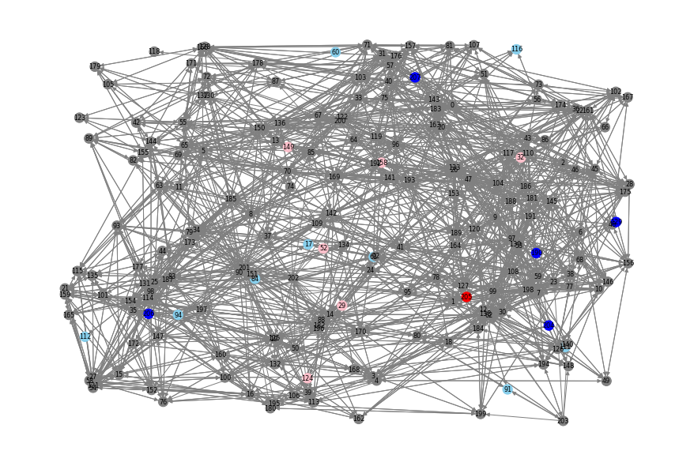

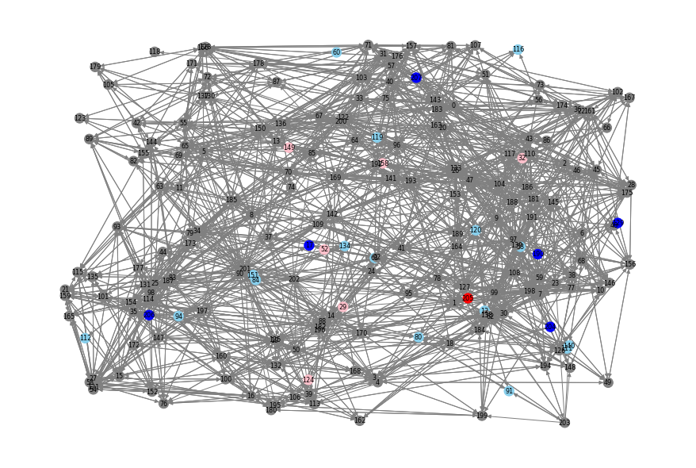

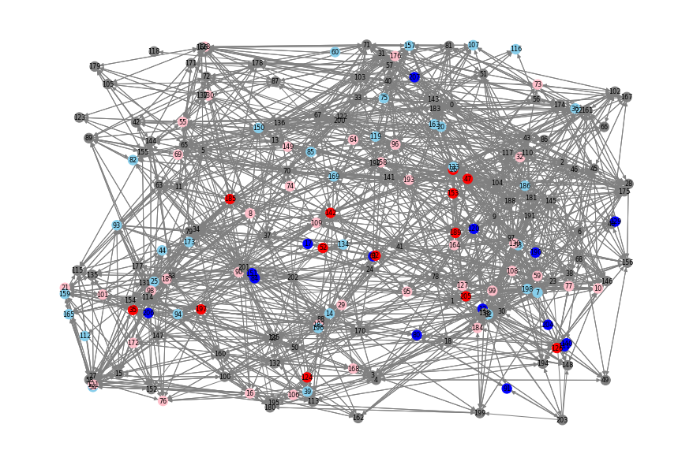

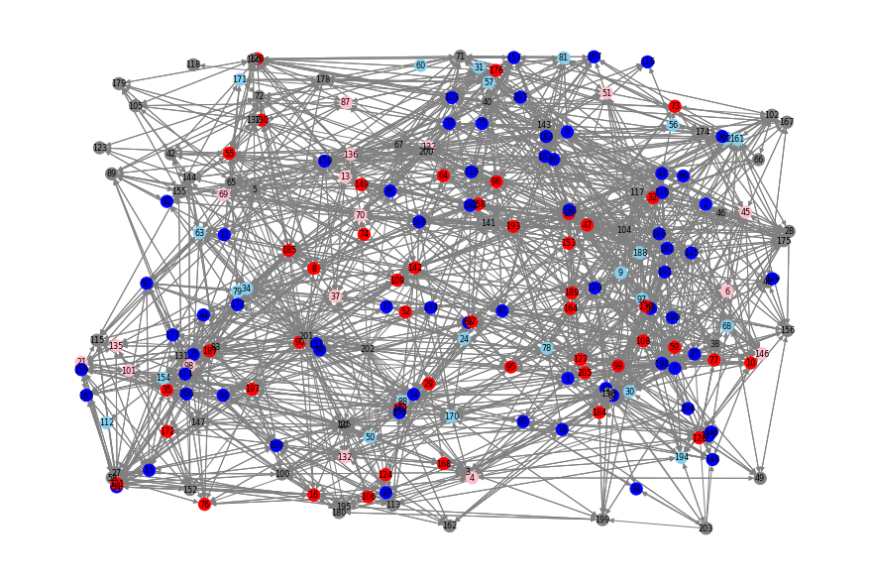

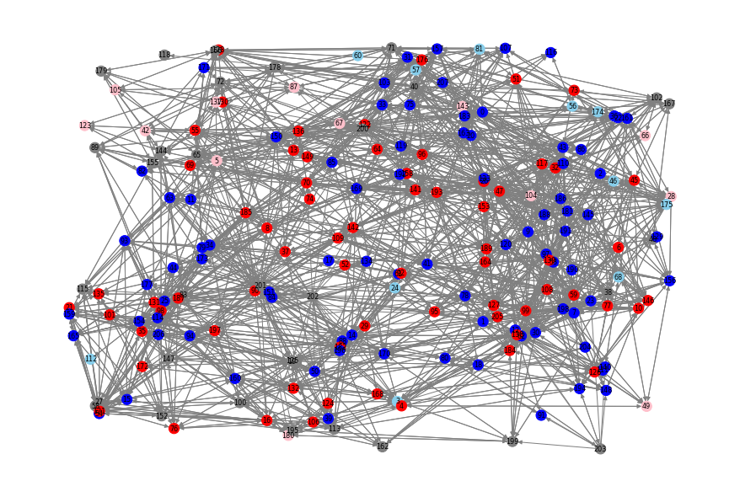

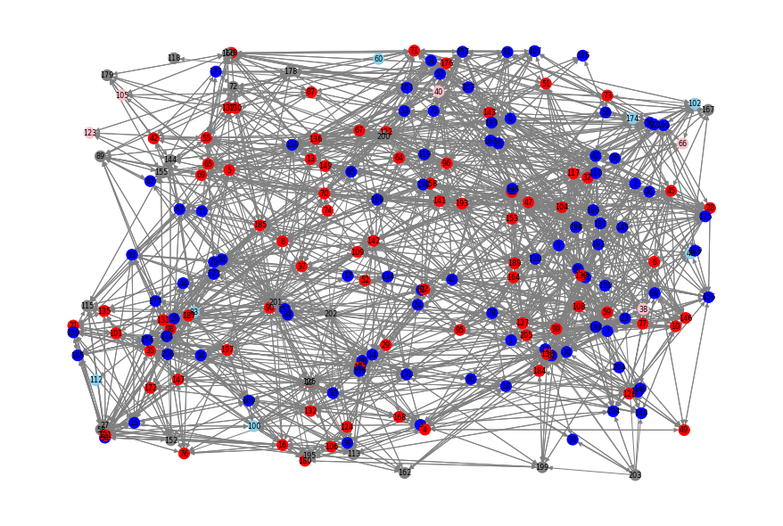

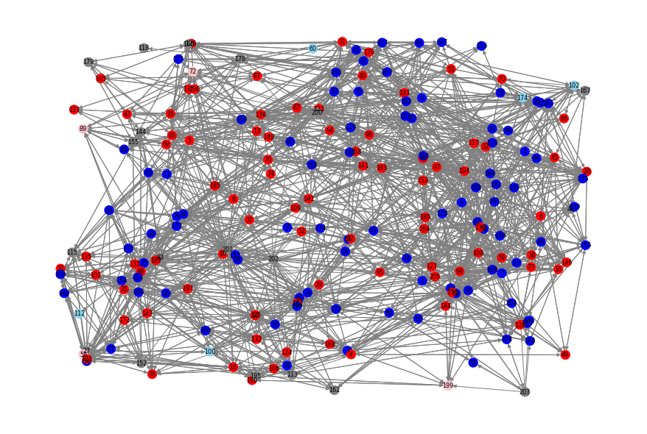

If we start from a situation where everyone is neutral. The political segregation will still happen:

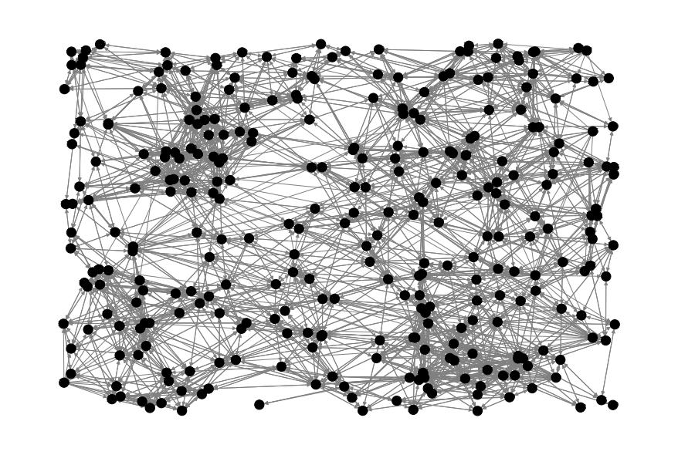

T=5

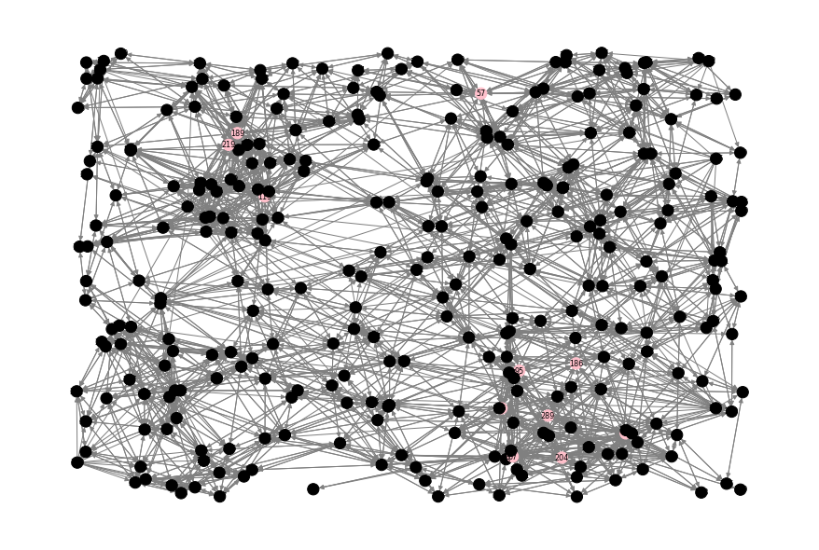

T=10

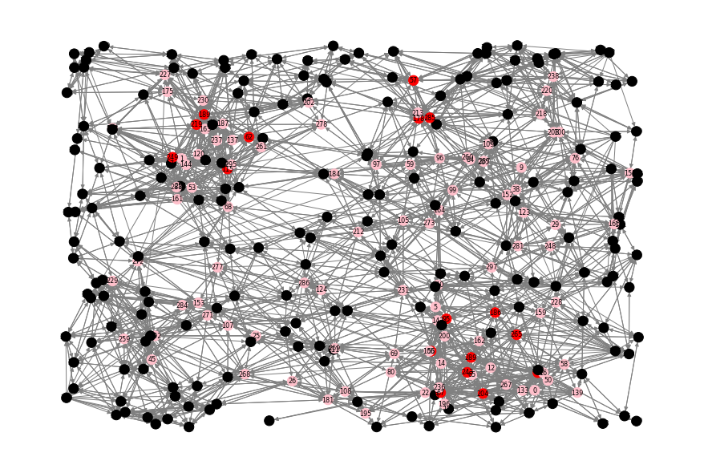

T=20:

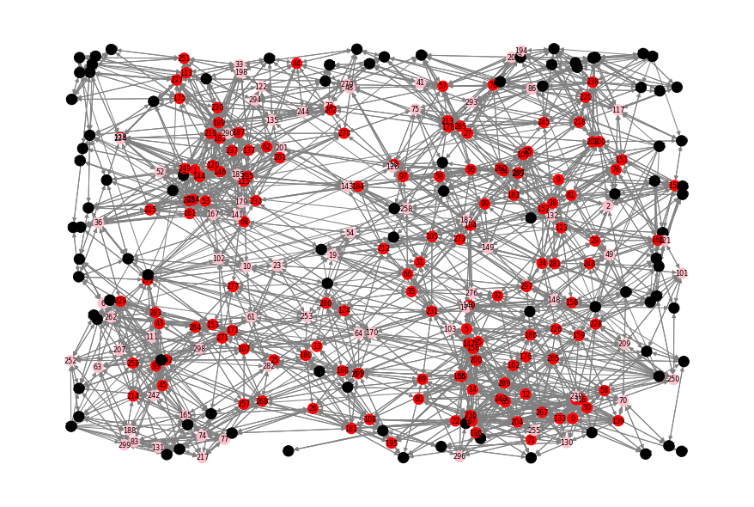

T=80:

